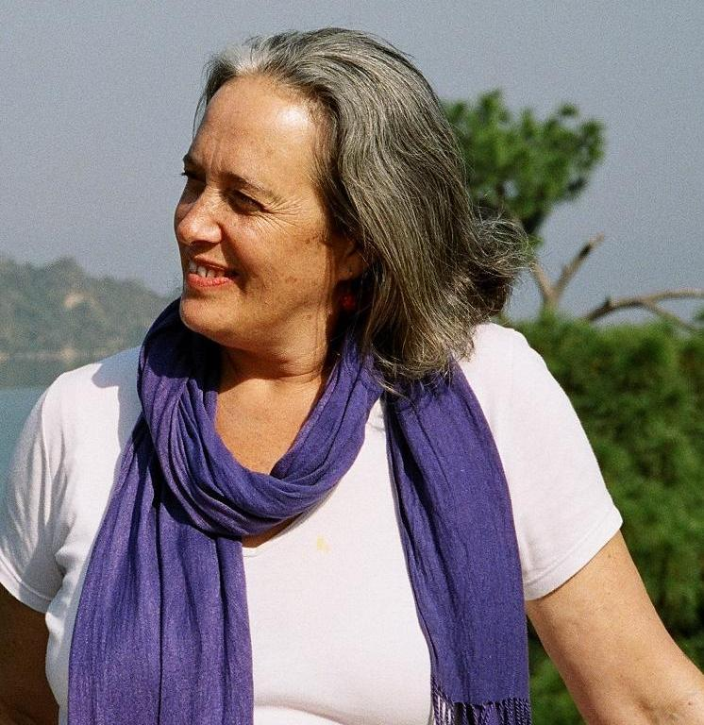

Michal Havkin is a prominent Israeli yogi who also worked as a professional dancer for over 30 years.

Michal’s yoga practice consists of slow, gentle movements. It respects the silence and includes the importance of listening. “The starting point of your yoga practice can begin at any given moment, you start wherever you are” she says.” Therefore, it is an activity that suits everyone - men and women, young and old, experts as well as beginners - everyone is welcome and no experience is needed to participate in the practice”.

Michal describes the yoga she practices and teaches as ”being connected to the breath, gravity and the space around us. It is a slow moving practice with constant awareness of the breath and the minute changes in our body each and every day”.

”My Yoga practice” says Michal, ”is about undoing, letting go, releasing, opening and softening with the wish to be quite, to listen”.

After more then 30 years of dancing professionally and teaching Modern Dance in Israel and abroad, Michal started studying Yoga. She found yoga practice to be very nutritious and enriching.

Michal has been studying and teaching together with Sandra Sabatini for the past 17 years.
Sandra Sabatini is the author of: “Breath - The essence of Yoga” Sandra herself studied with Vanda Scaravelli (the author of: Awakening the Spine) almost 18 years in Florence, Italy.

Michal has been studying Buddhism and Feldenkries technique for many years and has found a way to integrate these into her practice and teaching of yoga.

For more than 14 years, Michal has been teaching yoga groups and individuals in Israel as well as guiding workshops around the world.

